1. A fruit-seller varies the price of mangoes and records the weekly sales (number of mangoes sold):
Price (x) | 12 | 16 | 22 | 28 | 34 | 40
Sales (y) | 75 | 68 | 58 | 48 | 38 | 28

(i) Find the least-squares regression line of $y$on $x$.
(ii) Predict the number of mangoes sold when the price is 50 pence.
(iii) Calculate $R^{2}$and interpret the result.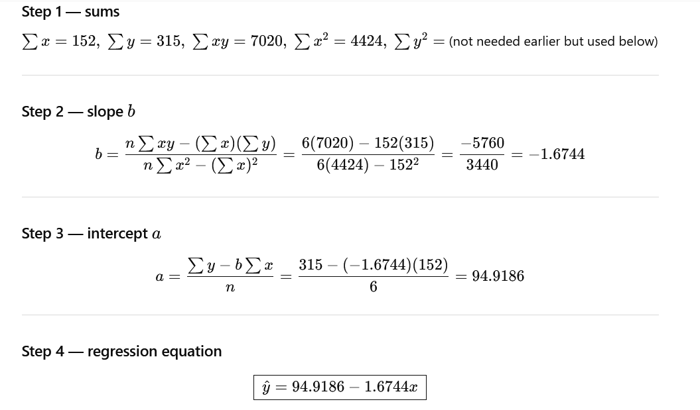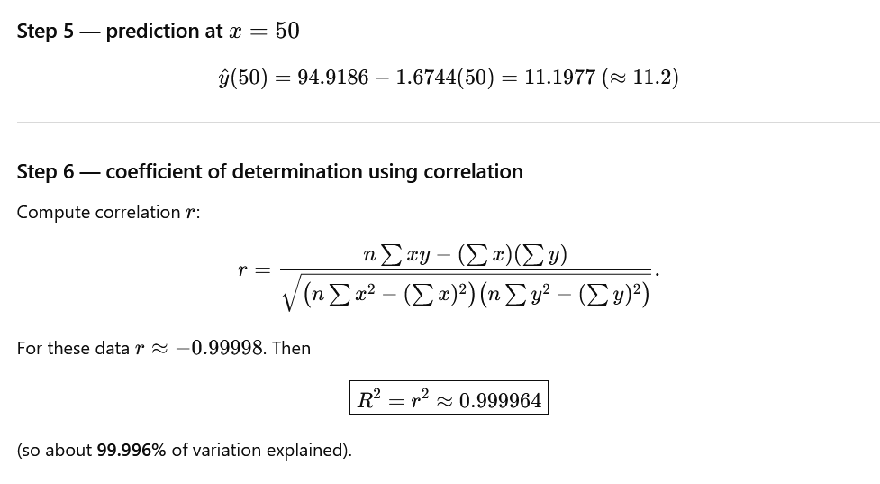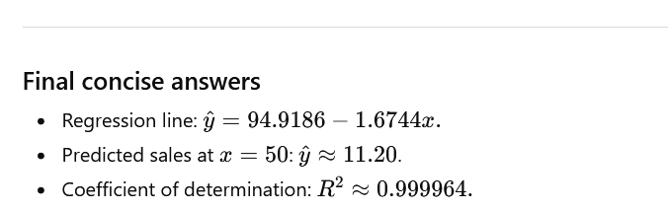

2. A market trader sells ball-point pens on his stall. He sells the pens for a different fixed price, x pence, in each of six weeks. He notes the number of pens, y, that he sells in each of these six weeks. The results shown in the following table
(x) | 10 | 15 | 20 | 25 | 30 | 35
(y) | 68 | 60 | 55 | 48 | 38 | 32

- Calculate the least square regression line y on x.
- Predict the number of pens when he sells for 45.
- Calculate the coefficient of determination R2 give me the similar problem
3. 